Tölvusamsetning og skýrsla / Computer synthesis

Processor - the brain of the computer
The processor is very often called the electronic brain - all because it is the most important integrated circuit in the entire computer and it is he who watches over the coordination of all components. The latest models have several or even a dozen cores, and each of them can independently perform the task entrusted to it or join forces with other cores and perform one large "project" faster. It is worth noting, however, that the performance of the processor is determined not only by the number of cores, but also by other elements of the specification (e.g. clock speed, cache memory and architecture).
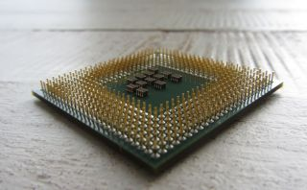
The picture above shows the processor (bottom view).
------------------------------------------------------------------------------------------------------------------------------
The motherboard - brings everything together
The motherboard is designed to connect all components and ensure efficient communication between them. The main feature of the board is the processor socket (e.g. AMD AM4 or Intel LGA 1151) and we should pay attention to it when choosing the right model. In addition, there are a lot of other connectors on board: banks for RAM, PCI and PCI-Express slots for expansion cards, slots for connecting disks, and in addition connectors for connecting peripheral devices. All these elements later affect the functionality of the computer.
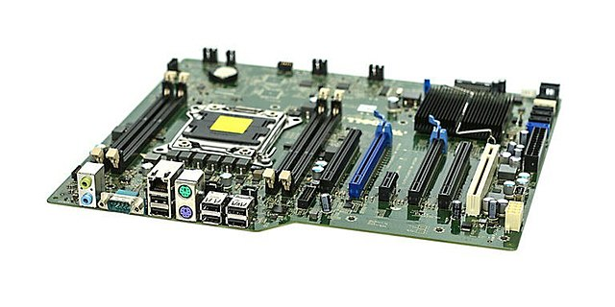
The picture above shows the motherboard (view from above).

RAM - Random-access memory
RAM stores all temporary information - mainly data of currently running applications, as well as the results of their work. It is said that the more memory available, the more efficient and comfortable the computer will work.
It is worth remembering, however, that the memory capacity is particularly important in professional applications, where the amount of generated data reaches several or even several dozen GB. In such cases, it is good to get more RAM (32 or 64 GB), while for a standard home computer, 8 or 16 GB is enough.
Currently, there are two generations of RAM modules on the market: the older DDR3 and the newer DDR4 (they are not compatible with each other, so it is worth looking at the motherboard specifications before buying).
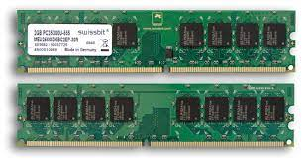
The picture above shows the Random-access memory (view from above).
------------------------------------------------------------------------------------------------------------------------------
Power supply - one of the most important components in the computer
The power supply is also one of the most important parts in a computer - all because it is designed to supply energy to individual components, and also protect them against possible power failures. The main feature of the power supply is the rated power, which determines the load capacity of the unit and how extensive the configuration it can handle.
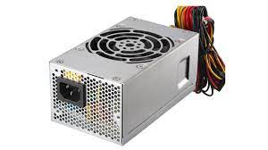
The picture above shows the power supply.
Hard drive - efficient SSD or capacious HDD
The hard drive is used to store all kinds of data - from the operating system and installed applications, through documents and generated program files, to your favorite movies, photos and music. The most important feature is therefore the capacity, because it depends on it how much data we will be able to fit on the disk. In addition, it is worth paying attention to the drive interface - the most popular is SATA 6 Gb / s, but in the case of more efficient designs, SAS, M.2 / U.2 or PCI-Express (as in the case of expansion cards) are used.
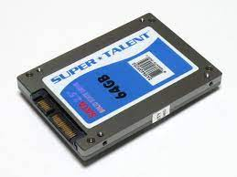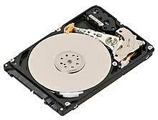
The picture above shows the SSD. |The picture above shows the hard drive.
------------------------------------------------------------------------------------------------------------------------------
Other Expansion Cards
The graphics card is the most popular, but it is not the only expansion card that we can use in a computer. Sometimes you can find good quality sound cards as well as WI-FI cards, TV tuners or all kinds of controllers - in most cases these are cards that use the PCI-Express interface, although older models still use the archaic PCI connector.
------------------------------------------------------------------------------------------------------------------------------
A computer fan
A computer fan is a fan installed inside or attached to a computer and used to actively cool its case. It allows cool air to enter and hot air to escape, or improves airflow through the component's heatsink.
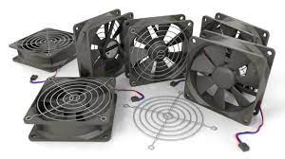
The picture above shows all kinds of computer fans.

